SIMATS ENGINEERING (SAVEETHA SCHOOL OF ENGINEERING)
Department of Computer Science and Engineering

ASSESSMENT TOOL 2 – Industry Problem Solving Task

Course Code: | CSA06 | Course Title: | Design and Analysis of Algorithms
 | CO4: Articulation (BL4, BL5)
 |  |  | Assessment Tool 2 –  Problem Solving Task | Industry
CO Assessed: |  | Assessment:
 | 20% of CIA
 |  |  | 100
Weightage: |  | Total Marks:
 | Solve optimization problems using dynamic progr |  | amming and greedy strate | gies.
CO4 Statement:
Student Name: | Y. Veera Reddy | Reg. No.: | 192211898
 | B Tech- CSE
 |  |  | 14-08-2026
Section / Batch: |  | Date:

Instructions to Students
- Answer the following question. Total Marks: 100.
- Carefully analyze the given questions.
- Explain in detail with sample code if needed.
- Clearly identify all key issues.
- Provide a thorough analysis with validated results and performance evaluation.

Question Type | Focus Area | Questions
Industry Problem Solving Task | Focus on Solving optimization problems using dynamic programming and greedy strategies | Q1

SECTION A – Industry Problem Solving Task

Q1. A software company must schedule multiple client meetings in limited time slots, ensuring maximum number of non-overlapping meetings. Analyze how the Activity Selection problem can be solved using a Greedy approach. Design a solution by explaining the selection strategy based on finishing times. Justify why the greedy method provides an optimal solution. Suggest suitable tools or programming techniques for implementation. Analyze time complexity and interpret the results in terms of efficient scheduling.

Code of Conduct
I _Y. Veera Reddy / 192211898 (Name / Reg No) certify that this submission is my original work and that I have adhered to the guidelines specified for this assessment. I understand that any violation of academic integrity rules will result in disciplinary action.
Signature of the Student: Y. Veera Reddy

RUBRICS FOR CALCULATION

Industry Problem Solving Task

Criteria | Weightage | Level 4 – Exemplary | Level 3 –  Proficient | Level 2 –  Developing | Level 1 –  Beginning
Understanding of  Industry Problem | 20% | Comprehensive understanding of  real-world problem and constraints | Good understanding with minor gaps in requirements | Basic understanding; some  requirements unclear | Poor understanding; misinterprets problem context
Application of  Engineering Concepts | 25% | Applies advanced and relevant concepts  effectively to solve the problem | Applies appropriate  concepts with minor errors | Limited application of concepts | Incorrect or no application of concepts
Solution Design | 25% | Innovative, practical, and feasible solution  aligned with industry standards | Logical and feasible solution with minor gaps | Basic solution with limited feasibility | Unclear or impractical solution
Use of Tools | 15% | Effective use of modern tools,  technologies, and real  data | Appropriate use of tools with correct implementation | Limited or inconsistent use of tools | Minimal or incorrect use of tools
Analysis | 10% | Thorough analysis with validated results and performance evaluation | Good analysis with reasonable validation | Basic analysis with limited validation | Poor or no analysis
Professionalism | 5% | Highly professional, well-documented,  and clearly presented  work | Good documentation and presentation | Basic documentation with some gaps | Poor documentation and presentation

Marks Evaluation:
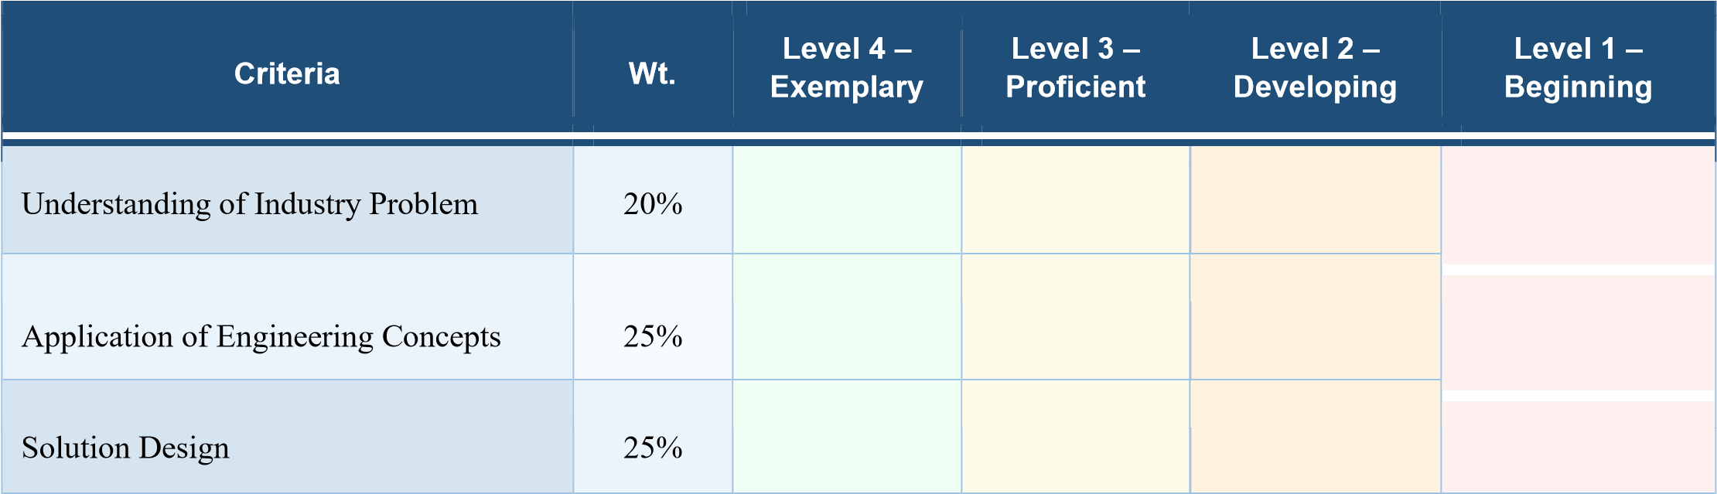


Faculty In-charge | Course Coordinator | Head of Department
Name: | Name: | Name:  Signature: _______________  Date: ___________________
Signature: _______________ | Signature: _______________
Date: ___________________ | Date: ___________________

Q1. Given a set of activities with start and finish times, select the maximum number of nonoverlapping activities using the Greedy Activity Selection algorithm.

1. Understanding of Industry Problem
- Clearly understands the real-world requirement of scheduling multiple client meetings within limited working hours.
- Identifies that meetings should be selected in such a way that no two selected meetings overlap.
- Recognizes that the main objective is to schedule the maximum possible number of meetings. • Understands that each meeting has a start time and finish time, which are the important parameters for scheduling.
- Relates the Activity Selection problem to practical applications such as meeting scheduling, conference-room allocation, appointment management, and resource utilization.

2. Application of Engineering Concepts
- Applies the Greedy Algorithm to solve the scheduling problem efficiently.
- Uses the concept of selecting the meeting with the earliest finishing time.
- Understands that selecting an activity that finishes earlier leaves more time available for subsequent activities.
- Applies algorithm design concepts such as sorting, selection criteria, constraints, and optimization.
- Demonstrates knowledge of time complexity and algorithm efficiency.
- Uses the greedy-choice property to obtain an optimal solution for the Activity Selection problem.

3. Solution Design
- The solution first accepts the number of meetings and their corresponding start and finish times.
- All meetings are sorted according to their finishing times in ascending order.
- The first meeting with the earliest finishing time is selected.
- The remaining meetings are checked one by one.
- A meeting is selected only when its start time is greater than or equal to the finish time of the previously selected meeting.
- This process continues until all meetings have been considered.
- The final selected meetings represent the maximum number of non-overlapping meetings.
- The design is simple, systematic, and avoids unnecessary calculations.
- The greedy strategy is optimal because choosing the earliest finishing compatible meeting leaves the maximum remaining time for other meetings.

4. Use of Tools
- Python can be used to implement the Activity Selection algorithm.
- Python's built-in sort() function can be used to arrange activities according to their finishing times.
- A suitable IDE, code editor, or online compiler can be used for implementation and execution.
- Test cases can be provided through standard input to verify the correctness of the program.
- Debugging tools can be used to identify errors and verify the selected activities.
- Basic programming constructs such as loops, conditional statements, lists, and sorting are sufficient for implementation.
- The solution does not require complex external libraries, making it easy to implement and test.

5. Analysis
- The activities are first sorted based on their finishing times.
- Sorting takes O(n log n) time.
- Selecting compatible activities after sorting takes O(n) time.
- Therefore, the overall time complexity is O(n log n).
- The space requirement is generally O(n) for storing the activities and selected results.
- The greedy approach is much more efficient than checking every possible combination of meetings.
- The results demonstrate that maximum meeting utilization can be achieved while avoiding scheduling conflicts.
- The method is suitable for large scheduling problems because of its efficient performance.
- The algorithm provides an optimal solution specifically because of the properties of the Activity Selection problem.

IMPLEMENTATION
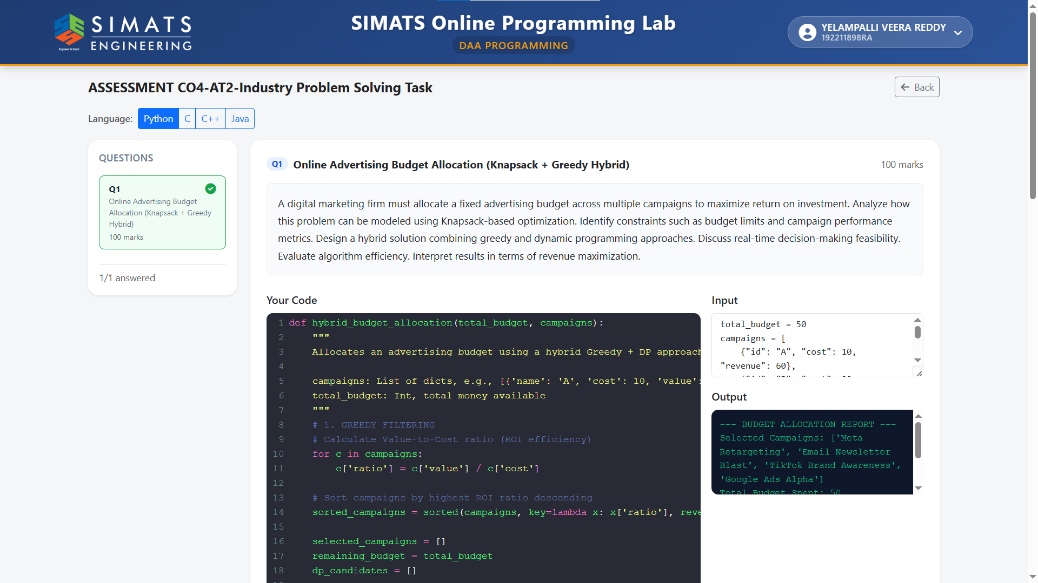

6. Professionalism
- Provides a clear and logically structured solution to the industry problem.
- Uses meaningful variable names and follows proper programming practices.
- Maintains readable and understandable code structure.
- Clearly explains the greedy selection strategy and why it works.
- Includes appropriate test cases to validate the implementation.
- Reports the time and space complexity of the solution.
- Presents the results in a professional manner that can be easily understood by technical and non-technical users.
- Demonstrates the ability to connect engineering concepts, algorithm design, programming implementation, and real-world scheduling requirements.

